Scenario 1: Process Monthly Interest
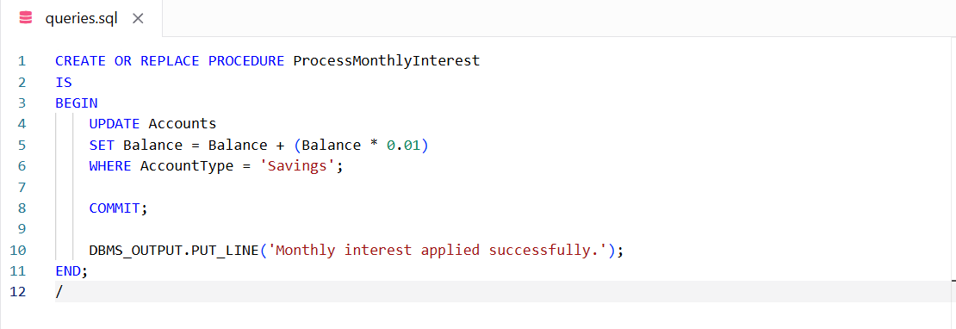

Scenario 2: Update Employee Bonus
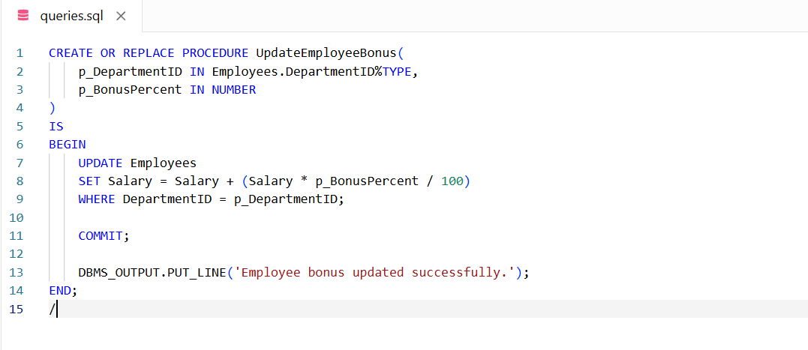

Scenario 3: Transfer Funds
